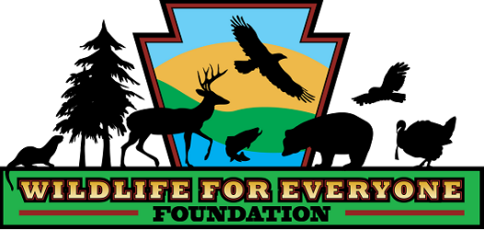 **DIRECTIONS TO**

**Tom Ridge Wetlands Preserve**

The Tom Ridge Wetlands Preserve is located between Julian and Port Matilda, PA.

The **GPS location is:** 40°50'23.00"N, 77°59'28.51"W (Latitude / Longitude).

The **address is**: 6535-6667 South Eagle Valley Road, Port Matilda, PA 16870.

**Directions from State College, PA**

Follow I 99 South.

Take Exit 68 (Grays Woods/Waddle).

Keep right where road divides (Waddle Exit.).

Go over Skytop Mountain.

At the bottom of the mountain, take US 220 North Ramp toward Milesburg.

Drive approximately 1 to 1 ½ miles. The Tom Ridge Wetlands Preserve will be on your right. Make a right over railroad tracks and into the parking lot.

(Note, if you see the Tom Ridge Wetlands Preserve sign, you have passed the entrance.)

Park in lot and follow mowed path that loops through the Wetlands. The Bald Eagle Creek forms the eastern boundary. The loop will bring you back to the parking lot. There is a bench at one of the viewing areas overlooking Bald Eagle Creek.

**Directions from Milesburg, PA**

Follow Route 220 South from Milesburg

Approximately 13.1 miles from where Rte 144 enters Rte 220 S

The Wetlands will be on your left, enter over the railroad crossing onto property.

If you pass the Church on the right hand side, you have gone past the entrance.

DRESS: Wear proper footwear. The property can be wet and muddy at times.